**Overview of the TMDB TV Shows Dataset**

The **TMDB TV Shows Dataset (2023)** contains detailed metadata about **150,000+ TV shows**, including information about their **genres, ratings, popularity, production companies, and more**. This dataset is useful for **analyzing trends in the TV industry, understanding viewer preferences, and making data-driven recommendations**.

**1️ Data Size and Format**

* **Size:** ~150,000 records
* **Format:** **Semi-Structured (JSON)**
  + The dataset is stored in **MongoDB**, which uses **BSON (Binary JSON)**.
  + Each document has **structured fields** (e.g., id, name, vote_average) and **semi-structured fields** (e.g., genres, production_companies, spoken_languages).
  + Some fields contain **lists or nested values**, making it **semi-structured** rather than strictly structured.

**2️ Key Features/Columns**

| **Field Name** | **Description** |
| --- | --- |
| _id | Unique MongoDB Object ID |
| id | Unique TMDB TV Show ID |
| name | Title of the TV show |
| first_air_date | Date when the show premiered |
| last_air_date | Date when the last episode aired |
| number_of_seasons | Total seasons of the TV show |
| number_of_episodes | Total episodes of the TV show |
| original_language | Language of the show (e.g., en, es, ko) |
| vote_average | Average rating of the show (IMDb-style) |
| vote_count | Number of user ratings |
| popularity | Popularity score based on TMDB algorithm |
| genres | Genres (e.g., "Drama, Crime, Sci-Fi") |
| status | Current status (e.g., Returning Series, Ended) |
| networks | TV network(s) that aired the show (e.g., Netflix, HBO) |
| created_by | Name of the creator(s) |
| origin_country | Country where the show was produced |
| spoken_languages | Languages spoken in the show |
| production_companies | Studios that produced the show (e.g., Warner Bros.) |
| episode_run_time | Average runtime of an episode (in minutes) |

**Storing Process:**

1 Created Cluster on MongoDB - MADSClass

2 Created Collection and Table – BIG_DATA and TMDB_RAW to store raw data.

3 Uploaded data from Kaggle Dataset to MongoDB using mongoimport:

Kaggle Dataset URL: *https://www.kaggle.com/datasets/asaniczka/full-tmdb-tv-shows-dataset-2023-150k-shows?resource=download*

*mongoimport --uri "mongodb+srv://madsclass.rgddjin.mongodb.net/BIG_DATA" --collection TMDB_RAW --type csv --headerline --file /Users/birajgtm/tmdb_shows.csv --username birajgtm --password birajgtm*

**Preprocessing:**

1 Removed unwanted columns:

2 Convert Boolean Fields from string to Boolean

3 Convert Date Strings (first_air_date, last_air_date) to ISODate

4 Convert genres from String to Array

5 Convert episode_run_time to integer and handle nulls

6 Convert vote_average to float

8 Check and remove duplicate records

9 Fix missing genres and origin_country

10 Verify Preprocessed Data

**Analysis:**

**Business Questions:**

What are the top 10 highest-rated TV shows?

How many TV shows are produced per country?

What are the most common TV show genres?

1. What are the top 10 highest-rated TV shows?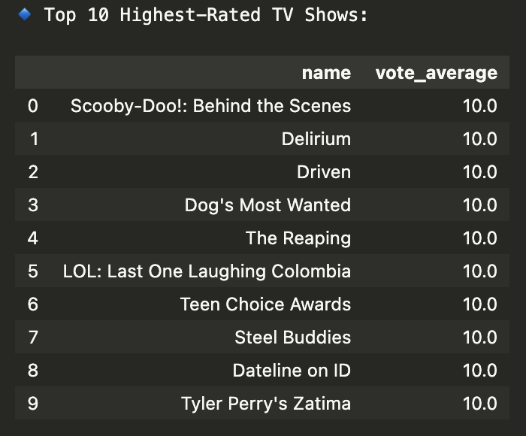
2. How many TV shows are produced per country?

1. What are the most common genres?

**Preparing and exporting data as CSV for MySql to proceed ETL Pipeline Design (SSIS):**

1 Exporting Data to CSV

2 Preview of the exported file:

